**Exp12 Code:-**

using System;

using System.Configuration;

using System.Data;

using System.Data.SqlClient;

using System.Windows.Forms;

namespace DBConExp12 {

public partial class Form1 : Form {

SqlConnection con = new SqlConnection(@"Data Source=.\SQLEXPRESS;AttachDbFilename=C:\Users\ameyk\onedrive\documents\visual studio 2010\Projects\WindowsFormsApplication2\WindowsFormsApplication2\Books.mdf;Integrated Security=True;User Instance=True");

public Form1() {

InitializeComponent();

}

private void button1_Click(object sender, EventArgs e) {

con.Open();

SqlCommand cmd=con.CreateCommand();

cmd.CommandType=CommandType.Text;

cmd.CommandText="insert into Books1(Title,Author,Publisher) values('"+textBox1.Text+"','"+textBox2.Text+"','"+textBox3.Text+"')";

cmd.ExecuteNonQuery();

con.Close();

textBox1.Text="";

textBox2.Text="";

textBox3.Text="";

disp_data();

MessageBox.Show("Record Inserted");

}

public void disp_data() {

con.Open();

SqlCommand cmd=con.CreateCommand();

cmd.CommandType=CommandType.Text;

cmd.CommandText="select *from Books1";

cmd.ExecuteNonQuery();

DataTable dt=new DataTable();

SqlDataAdapter da = new SqlDataAdapter(cmd);

da.Fill(dt);

dataGridView1.DataSource=dt;

con.Close();

}

private void button2_Click(object sender, EventArgs e) {

con.Open();

SqlCommand cmd = con.CreateCommand();

cmd.CommandType = CommandType.Text;

cmd.CommandText = "update Books1 set Title='"+textBox2.Text+"' where Title='"+textBox1.Text+"'";

cmd.ExecuteNonQuery();

con.Close();

disp_data();

MessageBox.Show("Record Updated");

}

private void Form1_Load(object sender, EventArgs e) {

disp_data();

}

private void button3_Click(object sender, EventArgs e) {

con.Open();

SqlCommand cmd = con.CreateCommand();

cmd.CommandType = CommandType.Text;

cmd.CommandText = "delete from Books1 where Title='"+textBox1.Text+"'";

cmd.ExecuteNonQuery();

con.Close();

disp_data();

MessageBox.Show("Record Deleted");

textBox1.Text = "";

textBox2.Text = "";

textBox3.Text = "";

}

private void button5_Click(object sender, EventArgs e) {

con.Open();

SqlCommand cmd = con.CreateCommand();

cmd.CommandType = CommandType.Text;

cmd.CommandText = "select *from Books1 where Title='"+textBox1.Text+"'";

cmd.ExecuteNonQuery();

DataTable dt = new DataTable();

SqlDataAdapter da = new SqlDataAdapter(cmd);

da.Fill(dt);

dataGridView1.DataSource = dt;

con.Close();

}

}

}

**Output:-**

**Insert:- Update:-**

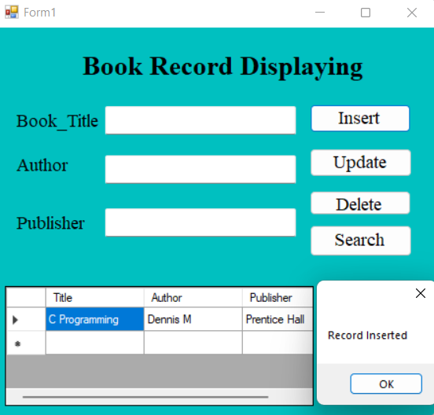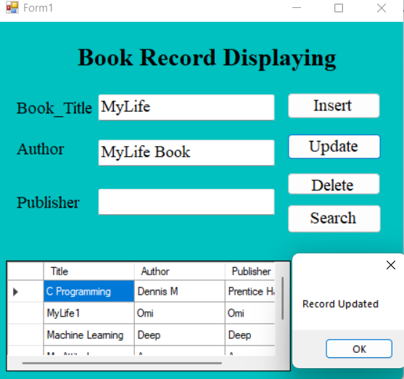

**Delete:- Search:-**

